K-ISMS Compliance for Log360
Strengthen cybersecurity and meet K-ISMS compliance with Log360.
Region: South Korea | Type: Incident Management | Category: Compliance | Pricing: Free

Overview
The K-ISMS compliance extension in Log360 helps organizations meet K-ISMS (Korea Information Security Management System Certification), mandated by KISA for ISPs, data centers, and large service providers in South Korea by providing centralized log management, continuous anomaly monitoring, and compliance reporting. The platform supports K-ISMS requirements for identity and access control, audit log collection and retention, log review and anomaly detection, security device monitoring, vulnerability management, incident response, and privileged account management across cloud and on-premise environments.
For Identity & Access Control (K-ISMS 2.5), Log360 monitors AD logon events, Windows logon/logoff, failed access attempts, and Unix logon activity to detect unauthorized access and enforce identity controls. To address Network & System Access Control (K-ISMS 2.6), the platform monitors network device logon, firewall rule changes, network security traffic, and remote sessions to enforce network access controls. The extension also supports Audit Log Collection & Retention (K-ISMS 2.9.4) by providing capabilities that centralizes event logs across AD, Windows, and application sources, providing audit reports to demonstrate collection completeness.

Key Features
- Log Review & Continuous Anomaly Monitoring (K-ISMS 2.9.5): Log360 detects Windows threat events, network attack reports, and antivirus alerts to enable continuous anomaly identification.
- Security Device & Malware Monitoring (K-ISMS 2.10.1, 2.10.9): Log360 ingests antivirus detection events, consolidated threat reports, and network firewall security logs to demonstrate security device operation.
- Vulnerability & Patch Management (K-ISMS 2.10.8, 2.11.2): Log360 tracks Windows software update events and detailed system events to monitor patch status and identify unpatched systems.
- Incident Response & Digital Forensics (K-ISMS 2.11.1, 2.11.5): Log360 provides real-time threat detection and system event records that serve as forensic evidence for incident reconstruction.
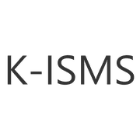
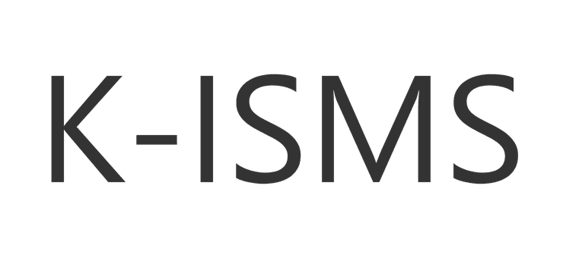

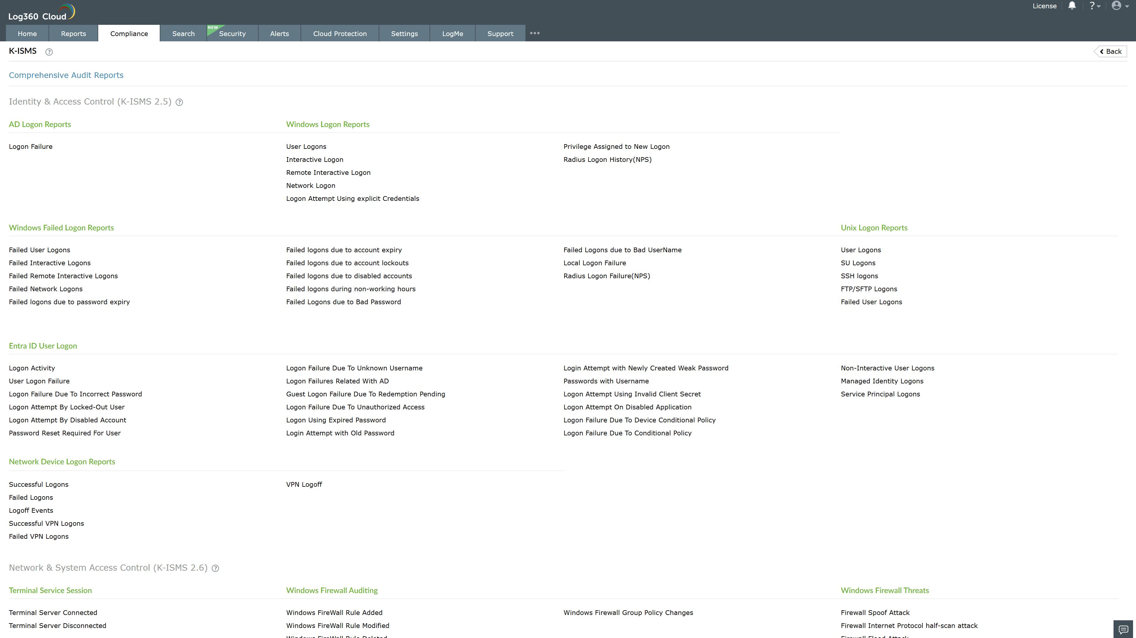
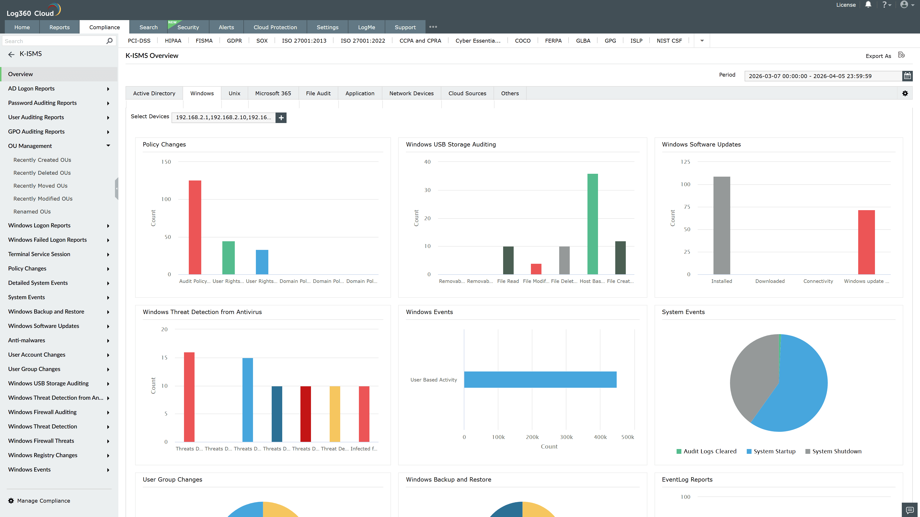
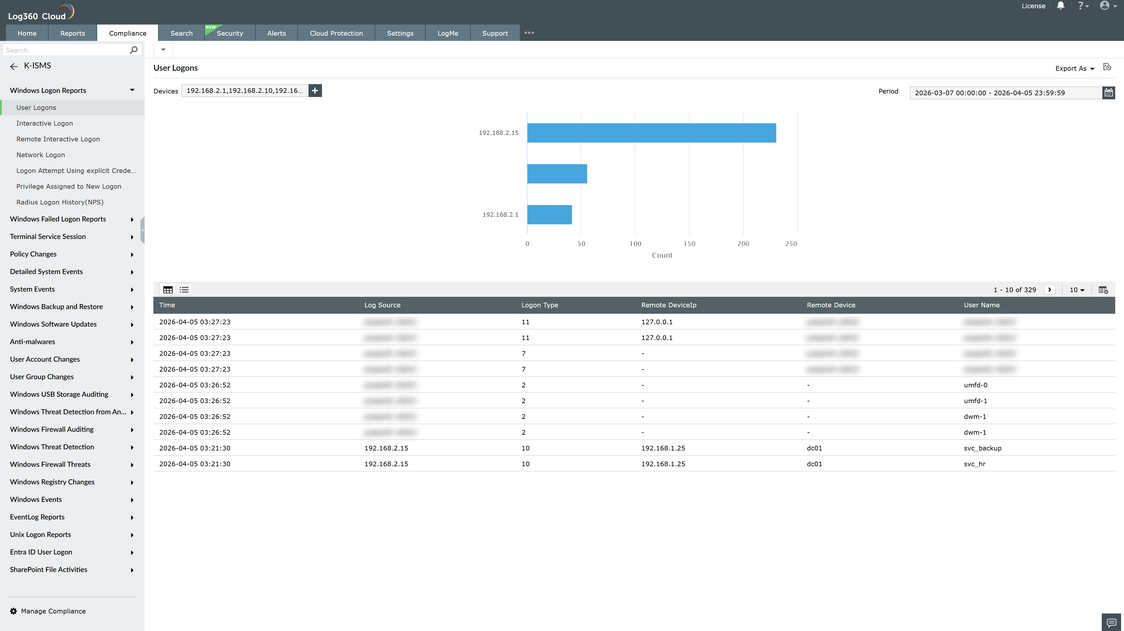
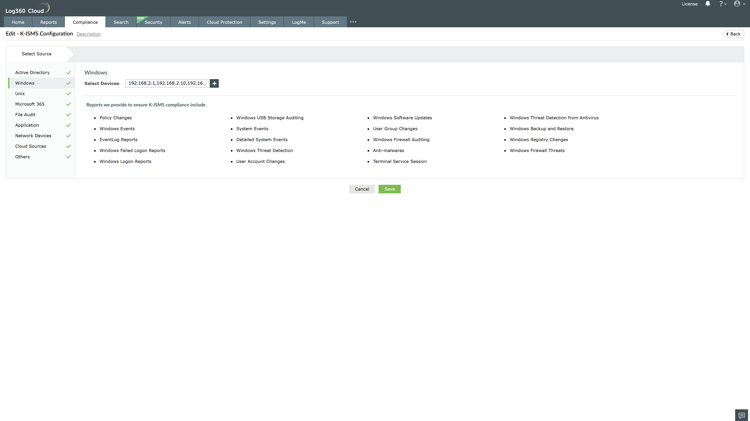
Valid Submission : Yes
Supported Editions : Free, Basic, Standard, Professional, MSSP
Help Document : https://www.manageengine.com/log-management/help/integrations/compliance-extensions.html
Help Video : Not provided
Tags : Log360, Compliance, Privacy monitoring, Data privacy, Regulatory compliance
Supported DCs : US, IN, JP, CA, AU, UK and EU
Privacy Policy:
Terms of Service:
Release Notes:
Predefined reports for the K-ISMS.

